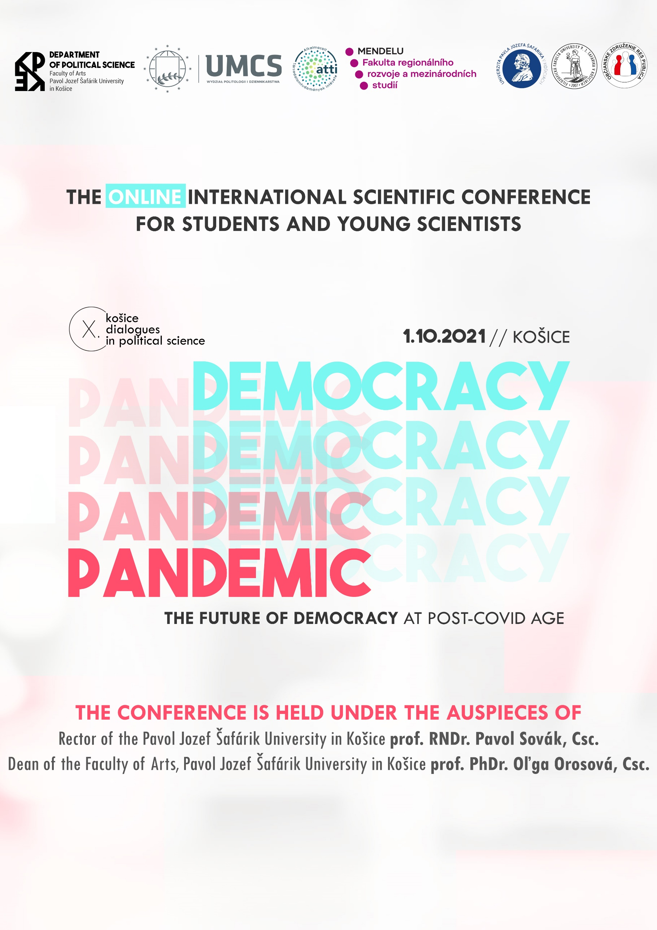

OPENING in Slovak (09:00 – 09:30)
prof. PhDr. Marián Andričík, PhD. |  | Vice-Dean for Research and Doctoral Studies, Faculty of Arts, Pavol Jozef Šafárik University in Košice
Dr.h.c. prof. PhDr. Marcela Gbúrová, CSc. |  | Head of Department of Political Science, Faculty of Arts, Pavol Jozef Šafárik University in Košice
1st PANEL (09:40 – 11:00)
09:40 – 09:55 | PhDr. Daniel Šárovec |  | Digitalizace a stranické akce: případová studie České republiky
 | Institute of Political Studies, Faculty of Social Sciences, Charles University, Prague
09:55 – 10:10 | Mgr. Dávid Gajdoščík |  | Slobodou proti slobode - protivládny protest 17.11.2020
 | Department of Political Science, Faculty of Arts, Pavol Jozef Šafárik University in Košice
10:10 – 10:25 | Mgr. Barbora Linhartová |  | Čína na západnom Balkáne (Koronavírus ako súčasť regionálnej a globálnej krízy demokracie)
 | Department of Political Science, Faculty of Arts, Pavol Jozef Šafárik University in Košice
10:25 – 10:40 | Tomasz Wicha, Ph.D. |  | Polish Constituional Court Abortion Judgment on 22nd October 2020 and its implications
 | Maria Curie-Sklodowska University, Lublin
10:40 – 11:00 | Discussion
2nd PANEL in Polish (11:10 – 12:40)
11:10 – 11:25 | dr hab. Mariusz Sienkiewicz |  | Problems of the Financial Management of Local Governments in Poland During the COVID-19 Pandemic
 | Maria Curie-Sklodowska University, Lublin
11:25 – 11:40 | dr hab. Katarzyna Kuć-Czajkowska |  | Local government units in Poland during the Covid-19 pandemic
 | Maria Curie-Sklodowska University, Lublin
11:40 – 11:55 | PhD Justyna Wasil |  | Problems of rural municipalities during the pandemic time/ Problemy gmin wiejskich w czasie pandemii
 | Maria Curie-Sklodowska University, Lublin
11:55 – 12:10 | Magdalena Lesińska-Staszczuk, PhD. |  | The impact of the COVID19 pandemic on the situation of women in society
 | Maria Curie-Sklodowska University, Lublin
12:10 – 12:25 | Dr. Ewelina Kancik-Kołtun, PhD.  Maria Curie-Sklodowska University, Lublin |  | Aktywność obywateli państw Grupy Wyszehradzkiej w czasie pandemii Covid-19/ Activity of citizens of the Visegrad Group countries during the Covid-19 pandemic
12:25 – 12:40 | Discussion
3rd PANEL in English (13:00 – 14:30)
13:00 – 13:15 | Dr. Sándor Fekete |  | The impact of the pandemic on the Hungarian local government system
 | University of Miskolc
13:15 – 13:30 | Daniel Kiss |  | State of Emergency - A Danger to Democracy?
 | University of Miskolc
13:30 – 13:45 | Benjamin Varga |  | Disinformation as an Instrument of Power
 | University of Miskolc
13:45 – 14:00 | Bence Csabai |  | Approaching the pandemic: Sweden's freedom or New Zealand's lockdown?
 | University of Miskolc
14:00 – 14:15 | Gergely Dózsa |  | The reaction of the people to the governments anti COVID measures
 | University of Miskolc
14:15 – 14:30 | Discussion
4th PANEL (14:45 – 16:00)
14:45 – 15:00 | Mária Denciová |  | Vplyv covid-19 na prezidentské voľby USA 2020
 | Department of Political Science, Faculty of Arts, Pavol Jozef Šafárik University in Košice
15:00 – 15:15 | Martin Šoman |  | Globalizmus a liberálna demokracia v post covidovej ére
 | Department of Political Science, Faculty of Arts, Pavol Jozef Šafárik University in Košice
15:15 – 15:30 | Mgr. Jana Gregová |  | Zlyhanie britskej vlády v reakcii na pandémie
 | Department of Political Science, Faculty of Arts, Pavol Jozef Šafárik University in Košice
15:30 – 15:45 | PhDr. Lukáš Jakabovič, MBA |  | Pandémia v zlyhávajúcich štátoch
 | Department of Political Science, Faculty of Arts, Pavol Jozef Šafárik University in Košice
15:45 – 16:00 | Discussion
CONFERENCE ENDING

Watch live stream of the conference on Facebook and YouTube channel of KPKE.
You can ask questions on Slido.
Visit Facebook event of conference.
For further information about the conference, please visit our website politologiaupjs.sk
or contact us on our contact e-mail stud.conf@politologiaupjs.sk

_ORGANIZERS _
- Department of Political Science, Faculty of Arts, Pavol Jozef Šafárik University in Košice
- Institute of Political Sciences and Administration, Faculty of Political Science and Journalism, Maria Curie-Sklodowska University in Lublin
- Department of Social Studies, Faculty of Regional Development and International Studies, Mendel University in Brno
- Department of Political Science, Faculty of Arts of the University of Miskolc
- Res Publica Civic Association

Scientific Committee
Dr.h.c. prof. PhDr. Marcela Gbúrová, CSc.
prof. PhDr. Ján Koper, PhD.
prof. PhDr. Svetozár Krno, CSc.
prof. Myroslava Lendel, Dr.Sc.
prof. PhDr. Ján Liďák, CSc.
prof. PhDr. Jozef Lysý, CSc.
doc. PhDr. Mgr. Josef Smolík, Ph.D., MBA, LLM
Dr. Ewelina Kancik-Kołtun, PhD.
Dr. Sándor Fekete
doc. PhDr. Vladimír Goněc, DrSc.
doc. PhDr. Daniel Dobiaš, PhD.
doc. PhDr. Peter Horváth, PhD.
doc. Mgr. Peter Juza, PhD., CSc.
doc. PhDr. Jaroslav Mihálik, PhD.
doc. PhDr. et Mgr. Peter Ondria,
doc. PhDr. Vladimír Srb, Ph.D.

Organizing Committee
doc. Mgr. Gabriel Eštok, PhD.
PhDr. Jakub Bardovič, PhD.
Mgr. Renáta Dulinová Bzdilová, PhD.
Mgr. Alexander Onufrák, PhD.
Mgr. Ján Ruman, PhD.
Mgr. Tomáš Dvorský, PhD.
Mgr. Barbora Linhartová
Mgr. Peter Dubóczi
Mgr. Dávid Gajdoščík
Mgr. Michaela Ružičková
Mgr. Patrik Furik
Mgr. Jana Gregová
PhDr. Lukáš Jakabovič, MBA

We are looking forward for your participation.

